Team 6: Code Masters

Project: RolePaymentSystem

Customer: Mrs. Ruth Ortiz

Leader name: Erick Tufiño

GitHub: https://github.com/Elxicor/ESPE-OOP145398-CM-PaymentRole.git

Inspector Team: 03, JEZHE Software Engineering Asossation, Jerson Llumiquinga M.

1. SISALEMA JIMENEZ YOSTIN ARIEL
2. TOSCANO CORO EDGAR DAMIAN
3. TUFIÑO ORTIZ ERICK ALEJANDRO

Evidence

1. GitHub Collaboration

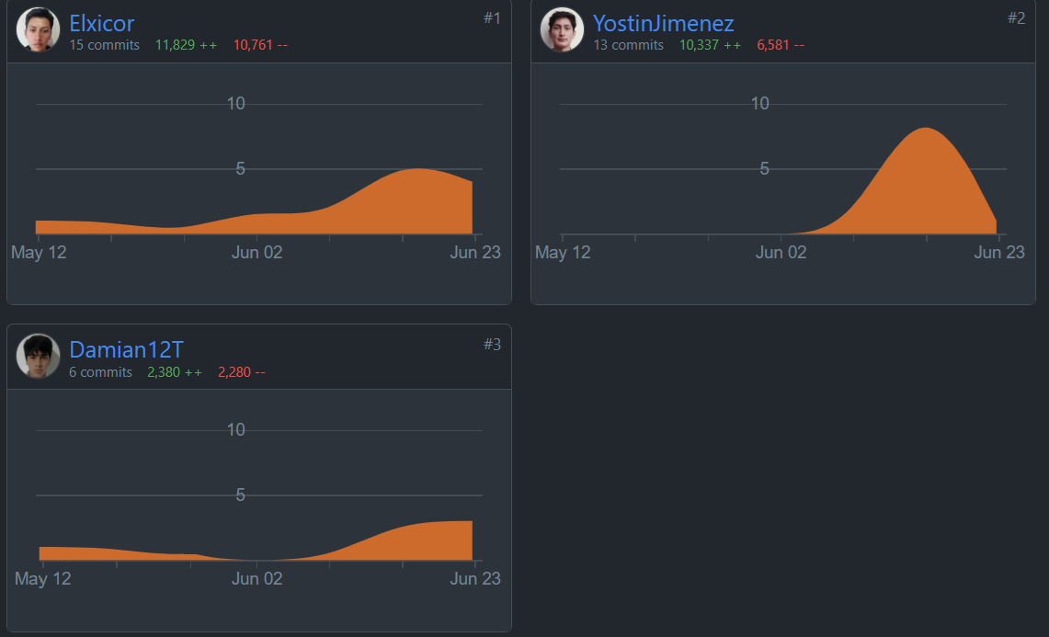

1. Attendance to Inspection Organization
2. Requirements

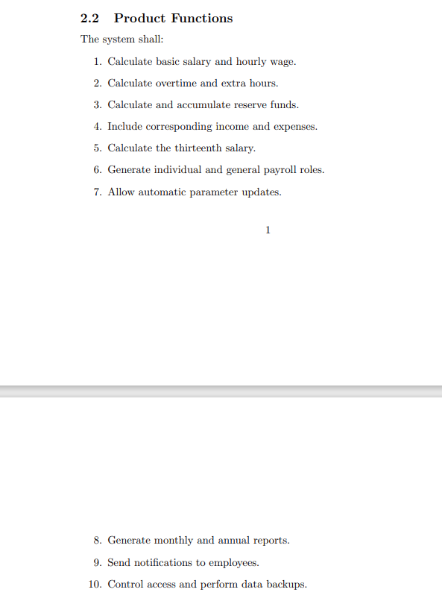

1. Modeling
   1. Use Case

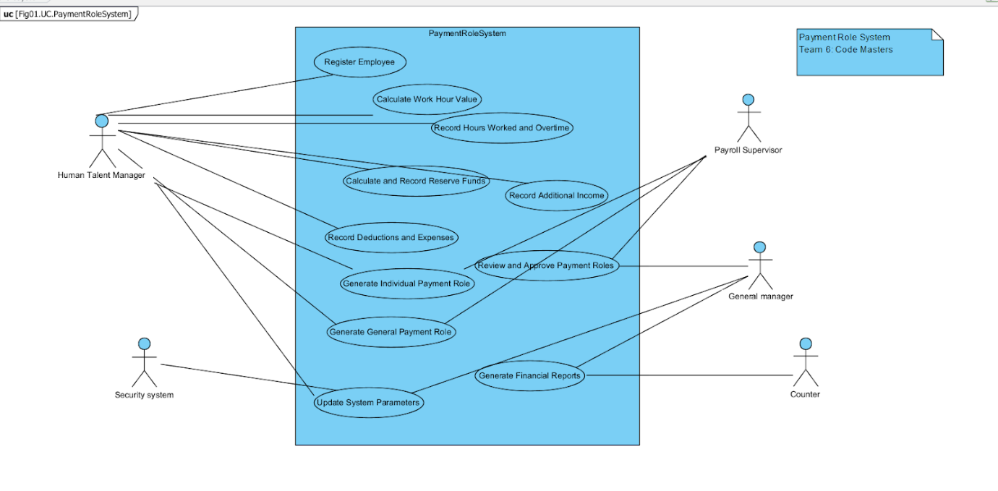

1. Class Diagram

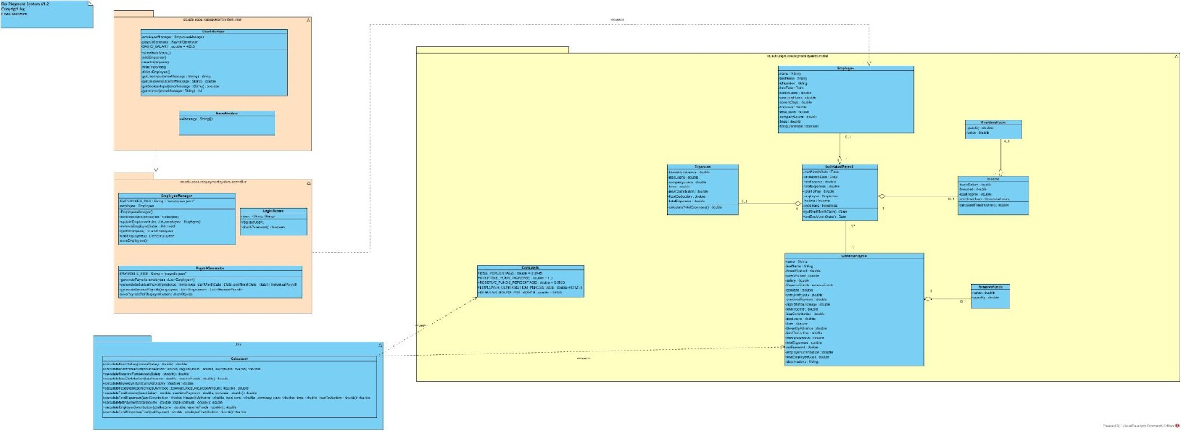

1. Code Structure consistency
2. Running the code
3. Clean Code

Rubric

1. GitHub Collaboration /100
2. Attendance to Inspection Organization /10
3. Requirements 9/10
4. Modeling
   1. Use Case 10/10

1. Class Diagram 9/10

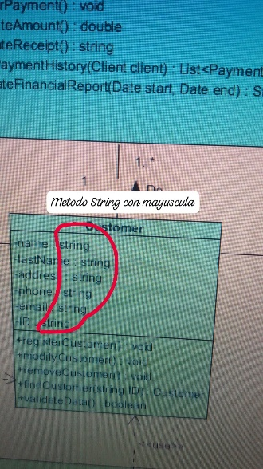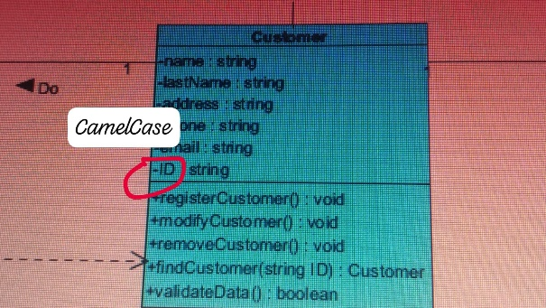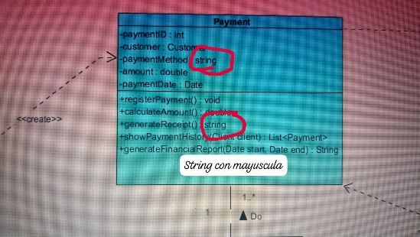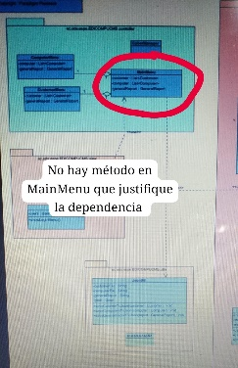

1. Code Structure consistency 9/10
2. Running the code 20/20
3. Clean Code /30

